Review of a book “The Witcher”
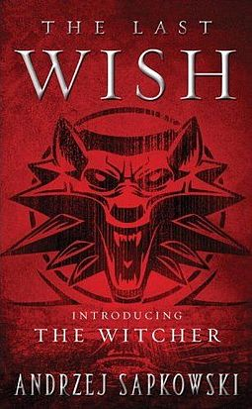 “And what is true manhood, if not confusing in the right proportions class and madness?”
The Witcher, first published in Poland in the early 1990s, by Polish writer Andrzej Sapkowski, is a collection of short, fantasy stories about Geralt of Rivia. In Sapkowski’s books, witchers are monster-hunters who receive special training and have their bodies modified at an early age to provide them with supernatural abilities so they can cope with dangerous monsters. The books have been adapted into a movie and television series, a video game series, and a graphic novel series. The novel series is also called the Witcher Saga or the Blood of the Elves Saga. The Witcher short stories and novels have been translated into several languages.
Witchers are taken in as children and subjected to potions and martial training for most of their young life. They have special powers, such as the use of low-level magical abilities based on the four elements, faster movement, rapid healing, quicker reflexes, and the ability to drink toxic potions that would harm normal people. The only downside is that Witchers become infertile when they pass the trials. Witchers also wear a magical medallion that will vibrate when magical creatures are nearby. They carry two swords. The first is a steel sword used against humans, and the second is a silver sword used against creatures like werewolves and vampires.
The book introduces us to Geralt, a human who underwent a series of experiments and mutations as a child to turn him into someone with both the strength and many skills. After a serious injury Geralt is recuperating in a temple. During his time there he recalls earlier incidents in his life, such as fighting monsters, or his first meetings with characters from the books and games, such as Dandelion the minstrel. This set up allows Sapkowski to give the reader an interesting introduction into both Geralt and the universe he inhabits.
In my opinion, the book is not boring even for a moment. The action is quickly developing and there are still many important things going on. Those, who like fantasy books, like Tolkien’s, may find the books by Sapkowski very interesting. I would recommend this book to all people. It is something, that makes you relaxed and cheerful. You are invited to the world of magic and dreams. You get to know fascinating creatures. You feel, what they feel and you go through many adventures with them.
Patrycja Misztal
Class II “a”
